%Transform pixels to meters for the quadratic form
resolution = 4;

the resoulation changed to 5, 3, 4

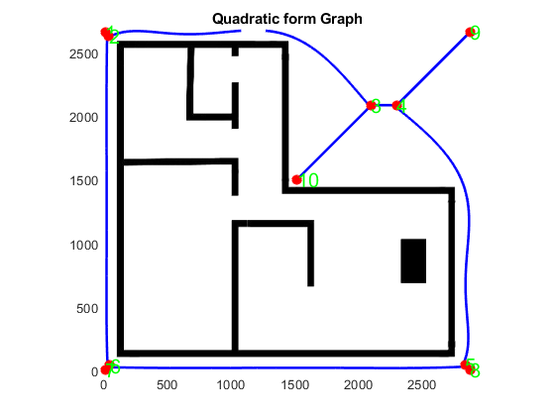
InputFileImage='Map8_2.jpg'; % input image, .jpg or .png
ROBOTRADIUS=5; % Rotot Radius

%Transform pixels to meters for the quadratic form
resolution = 1;

InputFileImage='Map8_2.jpg'; % input image, .jpg or .png
ROBOTRADIUS=3; % Rotot Radius

%Transform pixels to meters for the quadratic form
resolution = 1;

InputFileImage='Map8_2.jpg'; % input image, .jpg or .png
ROBOTRADIUS=1; % Rotot Radius

%Transform pixels to meters for the quadratic form
resolution = 0.2;

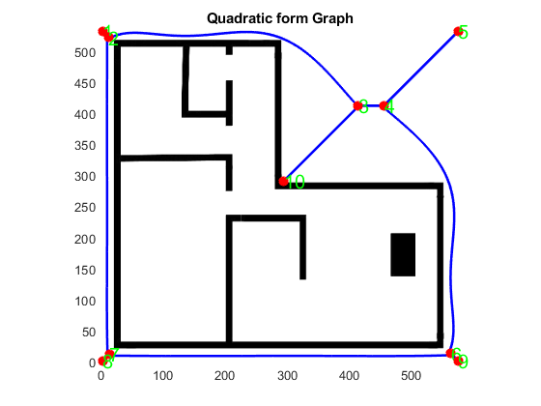
After editing the image with Microsoft word by adding another edge to the the image
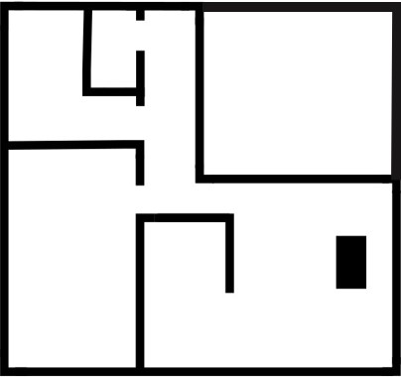
InputFileImage='Map3.jpg'; % input image, .jpg or .png
ROBOTRADIUS=1; % Rotot Radius

%Transform pixels to meters for the quadratic form
resolution = 0.2;

here are the results

The second image
InputFileImage='Map2.png'; % input image, .jpg or .png
ROBOTRADIUS=1; % Rotot Radius

%Transform pixels to meters for the quadratic form
resolution = 0.2;


